Establishing an Efficient Education Management Information System:

How to Facilitate the Activeness and Efficiency for the Language Faculty of Chinese University with Information Technology?

## Introduction

It seems like a typical phenomenon for many universities: lagging online course platform is wasting both teacher and student’s time; in addition, it is derailed from the aim of better accessibility for knowledge and encouragement for innovation and passion. The old-fashion and unreformed system is giving modern education a burden. Therefore, today, **the central research problem** in my research proposal is, in what way can we improve the education management information system so as to make it more efficient for language faculties (including streaming courses such as the Informatics). Of course, to call it an EMIS will be a big word, because actually the system is comprised of many smaller systems, like homework management system, course management system, student information system, human resources system, etc.

All in all, **the topics related to this research** includes education information management, homework management. With **methods** like doing surveys via setting up focus group and modelling, coding with flutter for web, JavaScript and CSS and finally testing via methods like white box test or black box test, we’re going to figure out what kind of design for education management information system could best facilitate teachers’ offline face-to-face education and inspire students’ passion and talents.

**We think this research topic is important and has realistic meaning,** not only because it can look into the reason why students and teachers have unsatisfaction towards the online education management systems, but also it can help solve out a practical way to enhance the user experience of these systems. According to the most updated researches, there has been some mature open-source education system developed, like Moodle or Blackboard; however, it seems in China they’re not getting popular, and I was thinking maybe this proposed study will more be down to earth and more related to the national condition, as well, we hope the final product could came out to be easily-commanded, for example, when teachers drag modules to the places they like and click “save”, they can soon finish the jobs of setting up a website.

## Key Words

Education Management Information System (EMIS), University Course Management System, Homework Management System, Language Learning, Flutter

## Background and Significance

As I have mentioned in the introduction part, today the central research problem in my research proposal is: in what way can we improve the education management information system so as to make it more efficient for language faculties (including streaming courses such as the Informatics). This is based on the reality that university courses have some inconvenient features: for example, unformatted homework submitting platform, inaccessible learning materials and the unclearness of both students and teachers towards the learning progress.

Why I concluded the core problems as such? First of all, as a university learner, I do appreciate that university has provided me with more autonomy in using digital devices and expand another way of learning for me; but at the same time, I feel confused because even with the help of technology, the learning efficiency seems not reach a higher improvement compared with that of high school. Another problem is that, since there’re fewer general quizzes in class in university, it became even harder for me to track my learning ability and get credible feedback, and the opaqueness of teacher’s marking made me quite confused when seeing the final GPA at the end of the term. In addition, I have confronted troubles such as uploading homework files but failed, be unaware of the deadline or detailed description of homework, or finding files from WeChat and mail were cleaned up and inaccessible. But imagine this: if we could improve efficiency with a simple management system website, we don’t have to jump from so many different platforms and worry about the accessibility of the files, right?

Apart from the student identity, I also detected from the perspective of teacher and found that the current system was like a burden for most teachers. For example, for teachers who focus on arts and literature, it’s not easy for them to build their own website even though with the open source SaaS platform like Moodle, and as a compromise, teachers are more likely to use traditional ways of teaching or homework submitting like e-mails or manually work out the statistics of students’ marks or performance. It’s time-wasting and hard to be managed. Of course, university can buy EMIS solutions from some consultancy providers like SAP or Oracle, however, it costs a lot and should bother the IT department to make a transform for all computer devices to install related software, which seems like a huge engineering project. Our goal is to set a uniform mobile and web platform which can be easily accessed to anywhere anytime.

Improve learning efficiency and management efficiency, that’s the two goals I’m going to look into in the later researches. Previously, I’ve talked about the methods I’m going to use in the research such as doing surveys via setting up focus group and modelling, coding with flutter for web, JavaScript and CSS and finally testing via methods like A/B test. Firstly, surveys can make us clearer about the needs of the target audience. It’s necessary for us to understand why most people in university have lower reliability of the current system, and also it would be even better for us to get data like DAU or MAU of some mainstream education products and to see which function page can best generate people’s interest. Secondly, after attaining certain knowledge, we can use Visio and mind map to draw some flowcharts and see how the system will normally work. Later, using Axure to do the prototype, and make work distributed to teammates, like who is responsible for the UI and who is responsible for the codes. The technology we consider to use here is flutter for web, JavaScript, CSS and SQLite; and also, we’re considering about using the python Django framework to help us with the web project. Finally, after finishing the project, we must do some tests like white and black box tests. It would be better if we can do A/B test, if say, we could gain a certain group of users.

All in all, before setting to do this project and related research, maybe it’s time for us to look into the former researches and see how this work is related and differentiated from the former ones.

## Literature Review

In fact, the concept of E-learning has begun to develop in the early 20th century. In the primitive days, people use technology like audio communication, TV broadcasts or video tapes to deliver lectures to remote audiences. However, the first mature learning management system (LMS) was developed during 1990s-2000s, which was called EKKO, and this marked as an embarkation of the new age of education technology. Nowadays, most modern learning management system are web-based, and it has following functions: it allows teachers to create and integrate course materials, articulate learning goals, aging content and assessments, track studying progress, and create customized tests for students.

Draw ourselves out of the history, let’s look at the most updated trend today. According to the statistics of the U.S. higher education market of fall 2018, the top three learning management systems by number of institutions were Blackboard, which took up 31%, Canvas, which took up 30%, and Moodle, 18%. However worldwide, Moodle is having a wider range of market share. But of course, in this research, we are going to focus more on the China market. According to China Learning Management System Market Reports provided by MicroMarketMonitor, the leading players in LMS market in China include Automatic Data Processing, Inc., Blackboard Inc., Cornerstone Ondemand, Inc, Desire2learn Incorporated and IBM Corporation. Also, according to part of the QYResearch’s report, we can learn that the main products of learning management system, in addition to the previous ones, also include Instructure, Moodle, Schoology, PowerSchool, and Edsby. In university, Moodle, Blackboard and XuetangX Cloud which is developed in 2017 for MOOCs are more frequently used.

What common features do these platform share? And what new feature can a system develop from the former one? I draw a chart below, and let’s see what kind of new discoveries we could have.

|  |  |  |  |  |
| --- | --- | --- | --- | --- |
| Category | Solution Providers | Main Features | Disadvantages | Applied Time |
| EMIS/CMS/LMS | Moodle | * All-in-one calendar. * Collaborative tools and activities. * Convenient file management. * Modular management * Detailed reporting and logs. * Embed external resources. * Manage user roles and permissions. * PHP * Mobile themes * Inline highlight | * No easy login method, unless your name is on the teacher’s list * Actually, the notice is not that easily-seen. * Students can’t get their overall statistics and studying trends | 2002 |
| Blackboard | * Preview course items, assignments, and tests * Participate in discussions * Send announcements * Interact with your class in Blackboard Collaborate * Grade assignments (Original courses only) | It always gets the users looking dirty and rough.  You may need regular maintenance in order to get the board really black.  The person who polishes it always gets dirty with black stains at the end. | 1997 |
| Schoology | * Advanced analytics. * Align content to Common Core and State Standards. * Automate grading system and performance-based analytics. * Automatically updating online grading system. * Calendars, messaging, and personal/shared content. * Centralize online educational activity. * Collaboration-based interface. | * Students can navigate away from the main educational focus and get distracted. * No two accounts can be open at the same time on a computer. * Student comments/discussions can not be moderated by teachers. |  |
| Desire2learn | * Customizable menu at the top of the course. * Quickly navigate to assignments, quizzes, and submissions. * Adding files was easy (drag-and-drop anywhere) and file structure was familiar. * Instructional Design Wizard. * Seating Chart – great for hybrid courses. | * Switching to student view is not always visible in course. * Shallow content organization structure – can be a pro. | 1999(2017: the first LMS to provide full capability on any mobile device using responsive web design) |
| Canvas/Instructure | * Quickly navigate to assignments and quizzes. * Option to set module process is right there when you are adding a new module. * Adding files was easy (drag-and-drop only to Files folder) and file structure was familiar. * Includes Course Setup Checklist. * Seating chart – great for hybrid courses. | * No option to customize course menu – only hide from students. * Switching to student view is not always visible in course. * Shallow content organization structure – lacks subfolders. | 2008 |
| Adaptive learning / AI | Songshuai AI, Xueba100 | For pupils or middle school students. Songshuai especially focus on Chinese teaching. | Limited subjects | 2014(songshu), 2012(xuebajun) |
| Automatically revising the tests | fclassroom | EI intelligent system | Not mature enough.  Mainly focus on K12. | 2014 |
| Facial recognition and intelligent matches | VIPKID(video teaching), 100tal/Xueersi | Could choose respective teacher according to your interest, making education an adaptive thing. | K12 learning  Sometimes not that adaptive  Frequently changing teacher is not that suitable sometimes | 2013 |

So, what features are typical? For example, homework assigning, students and teachers management, resources uploading. But some other features are not that common among all platforms, for example, only Moodle put forward functions like inline marking and peer review, and also, so far there’s no any platform could simultaneously give you a set of self-training test bank according to your mistakes and problem through learning. Also, the statistics are viewable to teachers, however students could not have an overall view towards themselves.

And since these platforms are mostly written in English documents, it became hard for Chinese University teachers to develop their own course and homework management system. I’ve read through some previous designs about management system in China, for example, in 2012 Jinan University has developed an online homework management system using ASP and B/S structure (Xu Shuaiwen et al., 2012), but nowadays it looks a little bit primitive and outdated though it did achieve basic functions for homework submitting. I think there’s a reason for it – we’re raising the standard towards UI and UX and therefore system which can’t adapt to mobile phones will soon be deprived of the main status. But of course, it’s still far better than using e-mails and repacking student’s homework.

Also, the previous researches also tell us the significance of carrying out a further research on the way of improving people’s learning passion through better management. In the 13th International Educational Technology Conference, it’s revealed that the effectiveness of the planning and the organizing of academic information systems at higher educations in the city of Bandung has been largely effective, which indicates a better management system will greatly enhance the learning efficiency for students as well as teaching progress for teachers. (Etin, 2013)

## Research Design and Methods

Based on the functions we are going to achieve, this part I’ll simply picture the overall structure and prototype and explain the reason. Of course, there might be some pitfalls and unexpected results, but all in all, with the following steps, maybe we can minimalize the possible failure in our project.

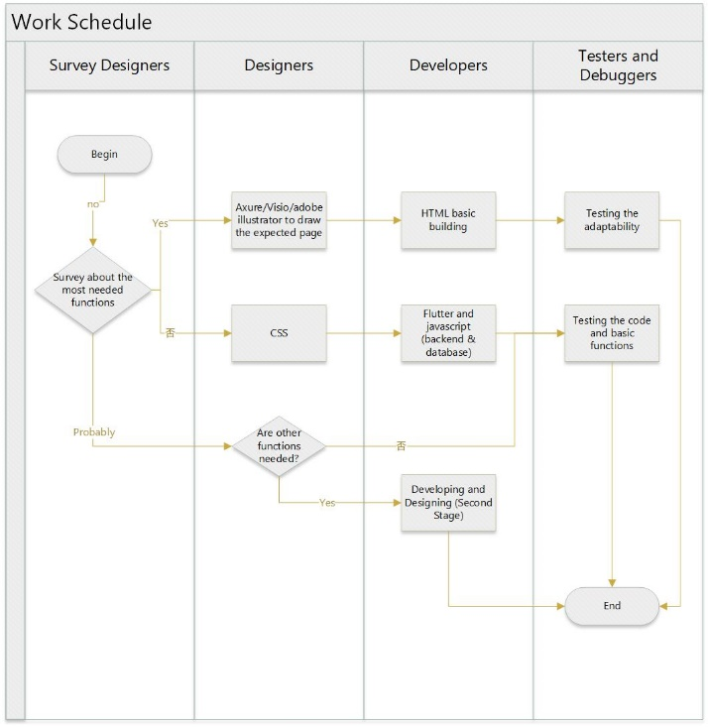

the overall working flowchart

Firstly, we should do a survey. According to UX design theory, it’s important to look into the psychology perspective of your target users. This part will include the investigation towards student’s courses, learning habits and the way they expect to get a feedback. And also, in order to encourage student’s learning passion, should we set up games or other rewarding system for them? How much do they like about this? Furthermore, as for teachers, we will do investigation about their age, computer proficiency and the frequency of using web. Also, we will look into what kind of goal they’re going to achieve in their courses, what they’re teaching and why sometimes they seem teaching inefficient. By learning the results, we can further design the functions.

Secondly, we make a design for the process via Axure and Visio to make the whole process easier to understand. Because we haven’t discovered any functions to be further developed yet, therefore, the core and basic features in our system are shown as below:

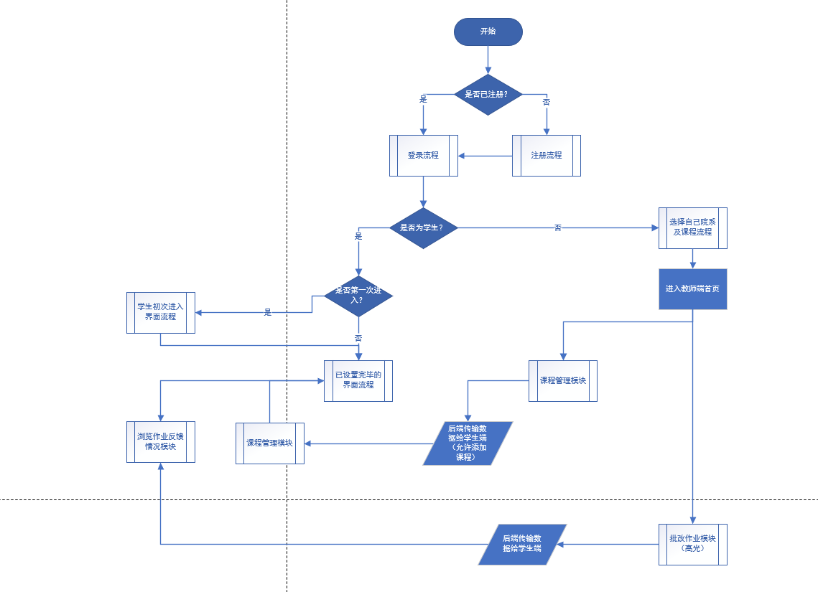

For the teacher end, the core features are listed as follow:

1. Create class and import class members
2. homework module
   * assigning homework
   * set a deadline
   * push important notice
   * pack student’s homework and download them in order
3. marking module
   * if the homework is a text-file (includes html files), teachers should be allowed to highlight and markdown on the platform
   * if the homework asks for codes, we could use JS Fiddle or CodeAnywhere to help view an online demo
4. feedback module
   * give student’s marks and track student’s learning progress
   * give students feedback
   * records for student’s homework

For the student end, the core feature are listed as follow:

1. Learning module
   * Add to the class
   * Join/ask for permission into the class they want to have
2. Homework module
   * Submit homework
   * See feedbacks from teachers or classmates
   * Peer review
3. Discussion forum
4. Adaptive learning
5. Recommended tests

Last, we set on doing the project with our own hands. The languages we are using are mainly flutter, JavaScript and CSS. We think in this part we will encounter some difficulties such as slow-paced server or limited space for database, but all in all we’ll try to solve problems out.

## Preliminary Suppositions and Implications

If the results can come up, I’m sure that some of the programs will be influenced, for example, a better education system to be adopted in Chinese market. And also, in university, a wider range of people will enjoy the efficiency. Of course, in may also have some implications towards the school’s education decision.

If we can set up a newer model of education management system, probably in the future, it will change the stereotype that all should learn according to what is given in the class and be evaluated by a single standard; furthermore, we hope it could provide a more helpful way of education, like how to improve efficiency, how to be adaptive? In this way, we hope that with the on-line platform students can learn and discover what they love and further their development in it; as for teacher, maybe it would be of help for them to recognize a good way for off-line education, and cut down wasted time in class and try to add some more energy into the off-line class through off-line feedback.

## Conclusion

In conclusion, with its reality meaning, the study is ought to be carried out because once it’s made, it can greatly enhance the efficiency of the education information system. To figure out the deeper reason for students unsatisfaction with education management system and make handing homework and learning knowledge a pleasure instead of a burden is both this study and project’s ultimate goal. And the research design and methods I’m going to use is basically up to date, and therefore I think choosing them is much better than other options. All in all, we’re going to figure out what kind of design for education management information system could best facilitate teachers’ offline face-to-face education and inspire students’ passion and talents

## Citations

1. "Learning Management System." *En.wikipedia.org*. N. p., 2019. Web. 5 Dec. 2019.
2. Indrayani, E., 2013. Management of Academic Information System (AIS) at Higher Education in The City of Bandung. *Procedia - Social and Behavioral Sciences, Volume (103),* 629-630.
3. Shuaiwen, X. Xiaoming, W. Song, L., 2012. On-line Homework Management System. *SciVerse ScienceDirect, Energy Procedia 17 (2012),* 691-693.
4. Pitukhin, E., Kekkonen, A. (2014). A Transparent information environment: an instrument to increase classical university effectiveness. *Proceedings of ICERI2014 Conference 17 th-19 th November 2014, Seville, Spain*, 5213-5220.
5. Kathy K. Archer, (2018), Practice. Practice. Practice. Do Homework Management Systems Work?, *International Journal for the Scholarship of Teaching and Learning, Volume (12),*1-5.